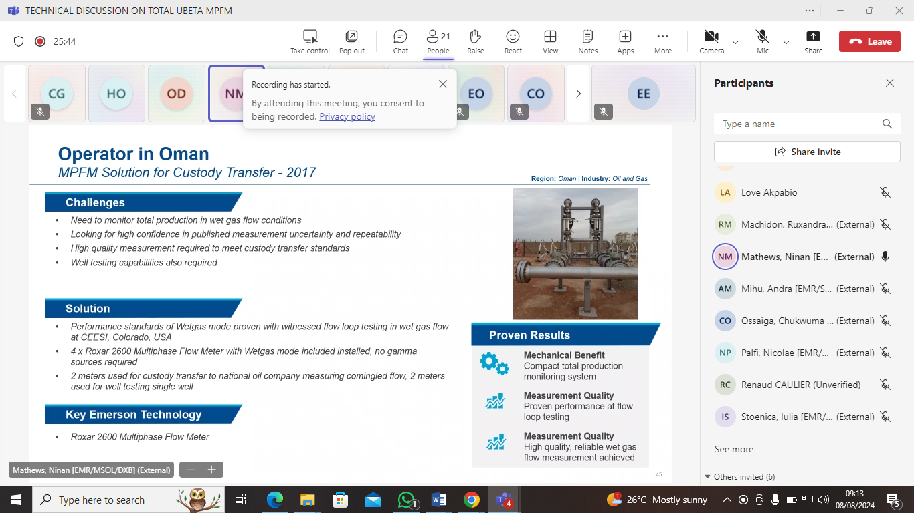

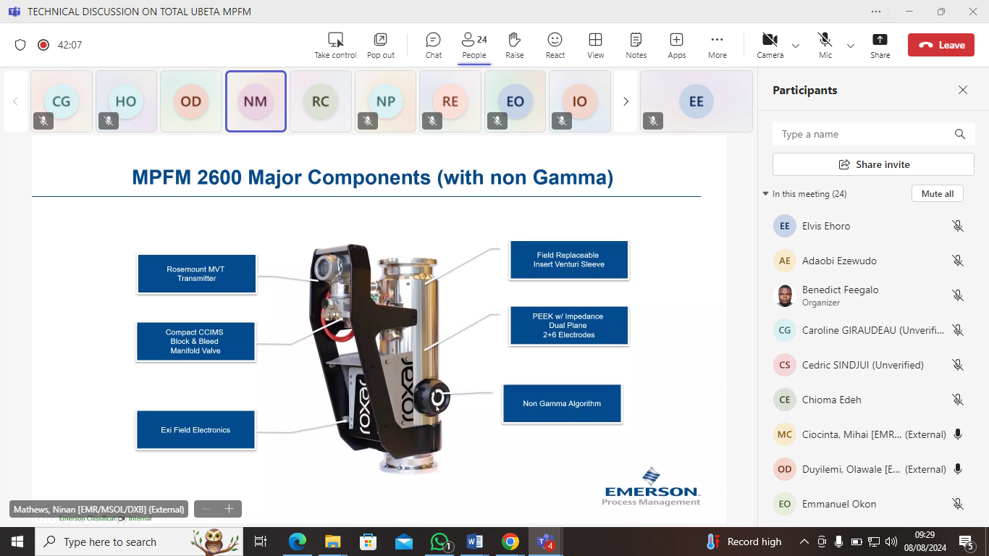

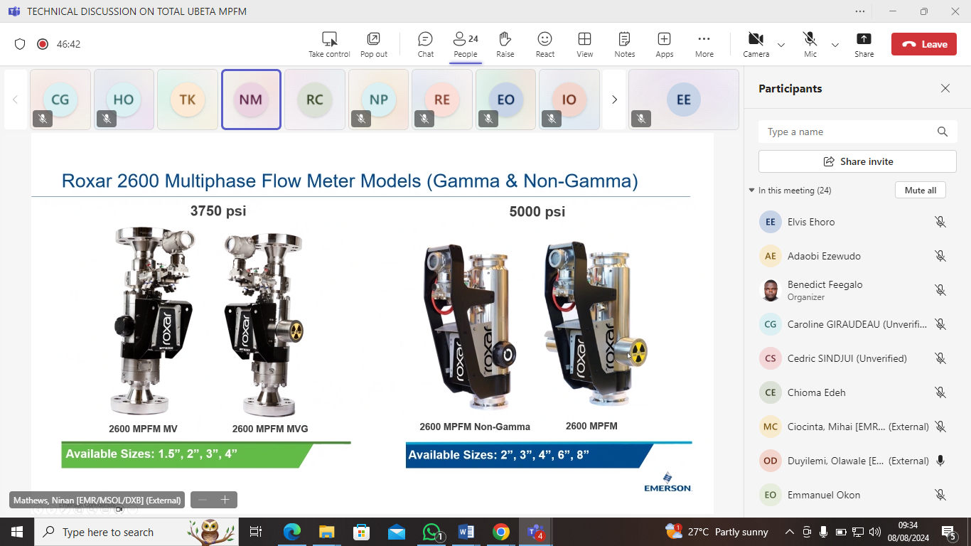

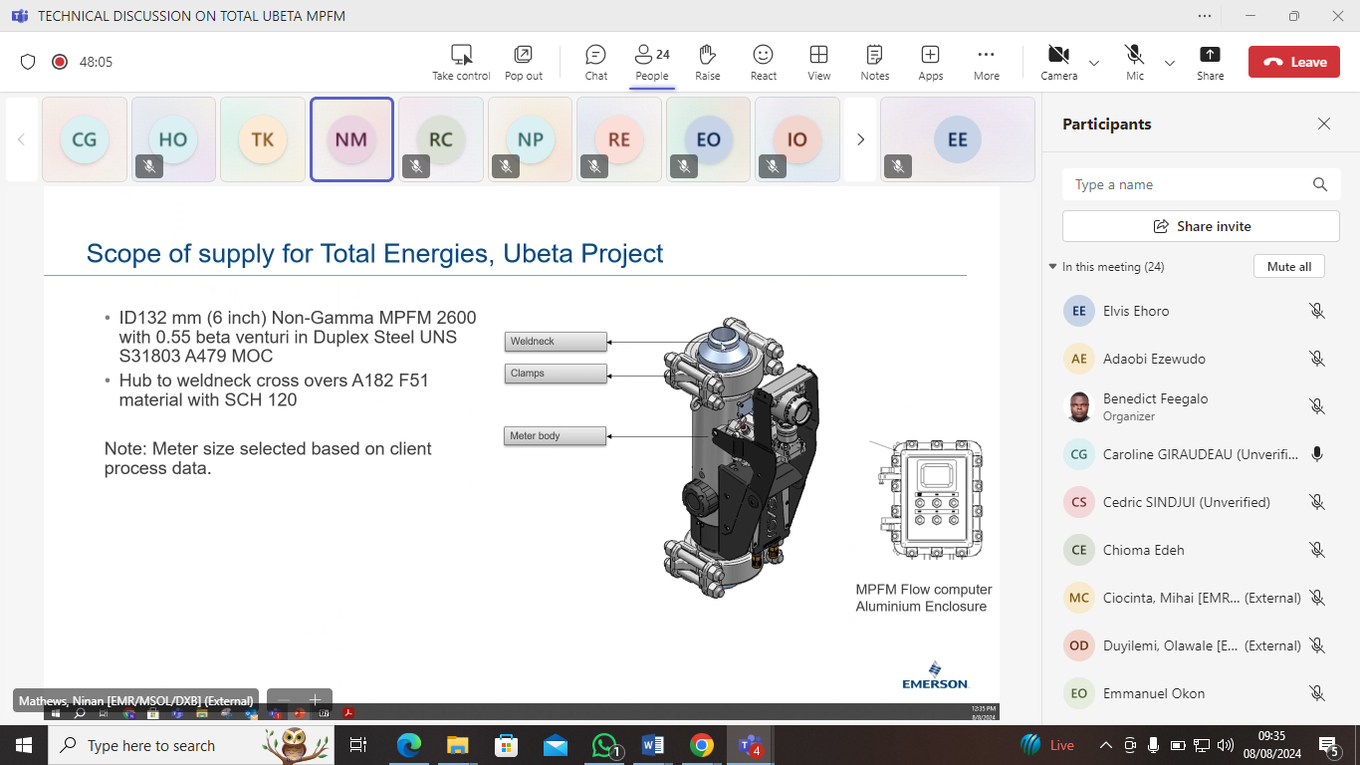

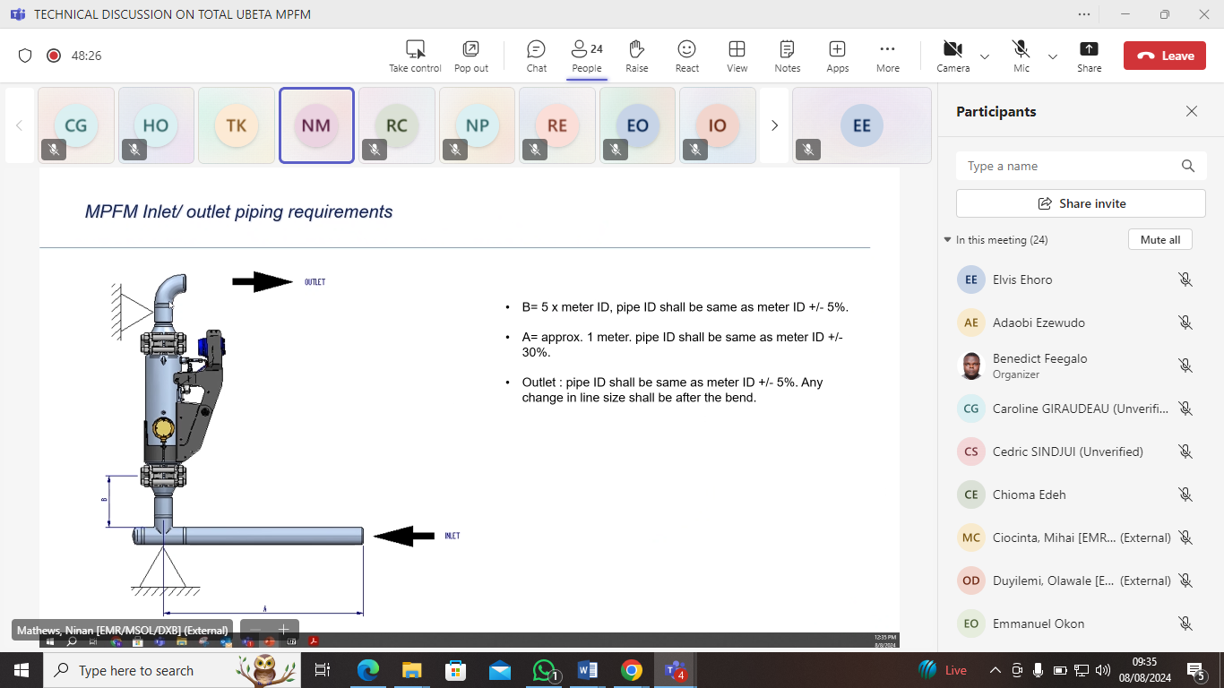

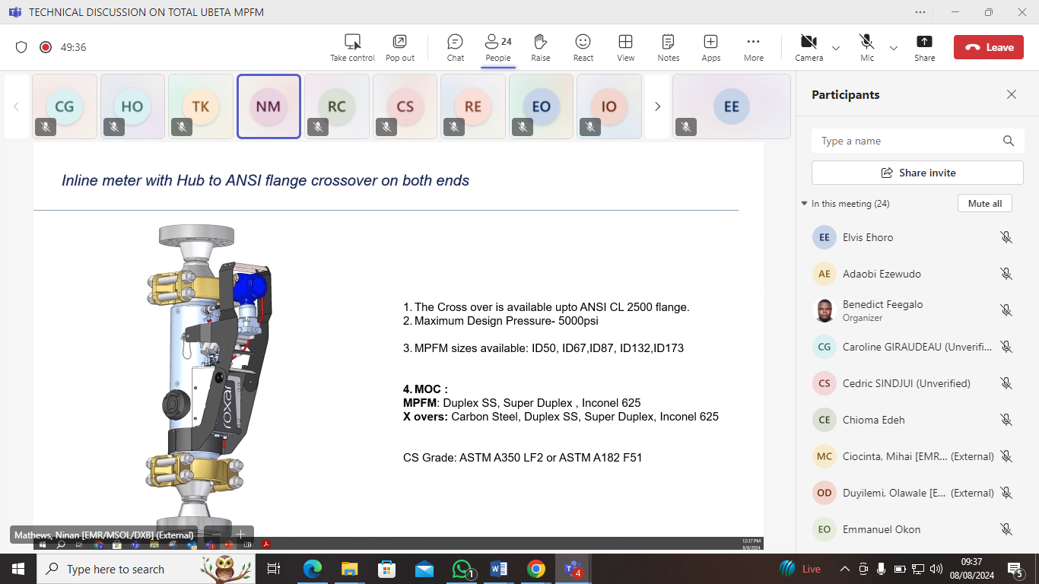

Actions for Emerson:

1.) EMERSON to provide the results of others applications MPFM in others companies with similar Wet gas GVF more than 98%.

2.) EMERSON to provide results of external flow loop test with similar Wet gas GVF more than 98%

3.) EMERSON to provide a detailed calculation of uncertainties specific for UBETA wells

